10 Fieldtrips in Kentucky Area

- List for me using the number button 10 places you would be interested in visiting on a fieldtrip.
- Write a paragraph for each place, and explain why you want to visit it!
- Insert 3 bullets of facts or cool things about the place you want to go!
- Insert a table with information about: Admission Cost, Contact Information, Available Times, Location. (Format the table so that everything is centered horizontally and vertically. Calibri Font, point 11. Choose which ever color table style you want)
- Insert 3 pictures. 1 picture needs to be a background graphic/ washout. 2 pictures need to have different picture effects on them. so that the words wrap around it. (Insert Comments explaining the picture effects you chose.
- Hyperlink the name of the place to a website so that you can get information from it
- Make the name of the place Size 18, bold, underline, italics, arial black font.
- Insert a header Top Right, First & Last Name, Date, Class Period
- Insert page numbers bottom centered.
- Insert an art page border around the document, width 12 pt.
- Use standard formatting (Calibri, Point 11) for the description and bullets. See example below:
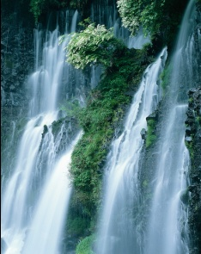
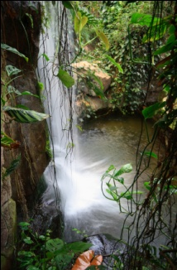
- Niagara Falls, NY
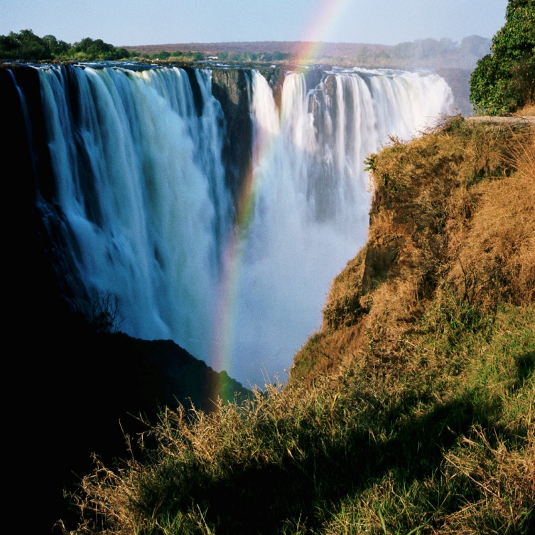
This would be a beautiful place for me to take my family. It looks beautiful on pictures and is a natural wonder for all to see. I feel like this would be a good trip for me, my son, and wife to get away and see the great outdoors. He loves water and I think he would be amazed at all the falls.
- Niagara Falls State Park is the oldest state park in the United States of America, established in 1885 as the Niagara Reservation, the first of several such Reservations that eventually became the cornerstones to the New York State Office of Parks, Recreation and Historic Preservation.
- In 1969, an earthen dam was built across the head of the American Rapids, dewatering the American Falls. For six months, geologists and engineers studied the rock face and the effects of erosion. It was determined that it would be too costly to remove rock at the base of the American Falls, and that nature should take its course.
- 3,160 tons of water flows over the falls every second. This accounts for 75,750 gallons of water per second over the American and Bridal Veil Falls and 681,750 gallons per second over the Horseshoe Falls.
Admission Cost | Contact Information | Available Times | Location
$8.00 | 724 – 999 – 6655 | 8:00 am – 8:00 pm | New York

