Name__________________________________________________
Chapter 7 Guided Reading
- Symbolically speaking, ____________________sits on top of _______________________ because it cannot run without the operating system and system utilities.

- You can purchase application software as _______________________or as a ___________.

- A suite generally contains the following four types of programs:___________________, _________________________,_____________________ , and__________________.

- You use _________________________software, like Microsoft Office Word, to create, edit, and print documents and then save the documents electronically.

- Word processors that support the basic features generally are called______________________.

- Microsoft Word provides options that you can adjust and configure to suit your working style. To display the Word Options dialog box, click the _____________________and then click the _____________________button at the__________________ of the menu.

- A ___________________is a row-and-column arrangement of data.

- You use electronic spreadsheet software, like Microsoft Office Excel, to______________, ___________________, ____________________, _______________, and _________________numeric data.

- The rows and columns can contain ________________,__________________ , and ____________________.

- The grid in Excel is referred to as a _______________ (or ___________________).

- An Excel file is called a _____________________.

- A_____________ is the intersection of a _____________and a ________________.

- Each cell has a name, called the _______________________(for example, A1).

- You can use __________________ to emphasize specific entries, enhance the appearance of the spreadsheet, and make the information easier to read and understand.
- Presentation software, like _________________________________, is a computer program you use to _________________and ____________________ information, normally in the form of a slide show.

- Microsoft PowerPoint comes with_________________–predesigned sets of fonts, colors, lines, fill effects, and other formatting.

- Summarize below the effective presentation guidelines:

- Effective _______________________________ is the core of a successful business or organization and is important in your personal life.
- A _____________________ is a collection of related information organized in a manner that allows for rapid search and retrieval.
- A ____________________________________________ (DBMS) is a software program that is used to _____________, _________________, and __________________controlled access to data.
Database Structure:
- A _________________________ is composed of columns and rows, referred to as ______________ and ___________________ in Access.
- The _________________________, which is assigned to a field, uniquely identifies each record in a table.

- Using the data stored in the table, you can use Access to create the following objects: ________________, ______________, and _________________.

- ____________________________is the first step in a three-step process and _________________________ is the second step. The third step is to ________________ or add records to the table.

- Access contains two basic views for working with tables—______________ view and _________________ view.

- A _______________ provides a convenient way to enter and view records in a table.

- A _________________ enables you to locate records that match specified criteria by providing a way for you to ask a question about the information stored in a database table or tables.

- A _____________________is a database object that allows you to ______________, ________________, and ______________ all or a portion of the data in a database.

- Many ____________________________databases are dynamic and provide the capability for the user to change the content and products frequently.
- You use graphics and multimedia programs to create a variety of illustrations and animation.
Fill in the Table Below: (Video, Graphics—Pictures, Sound)
Image Type | Description
GIF
JPG
MOV
MP3
Important!!!
PNG
QuickTime
SWF
WAV
MP4

- A ________________________is a graphics program that is used for creating illustrations.

- The image is saved in a____________________________. This allows all individual parts of the picture to be moved, isolated, and scaled independently of the other parts.
- ___________________________is defined as the use of text, graphics, audio, and video in some combination to create an effective means of communication and interaction.

- Provide Examples below of Education and Entertainment programs.

- Provide Examples below of Utility programs.

- Provide Examples below of Miscellaneous Software programs.

M
J
K
I
L
H
G
F
E
D
C
B
A
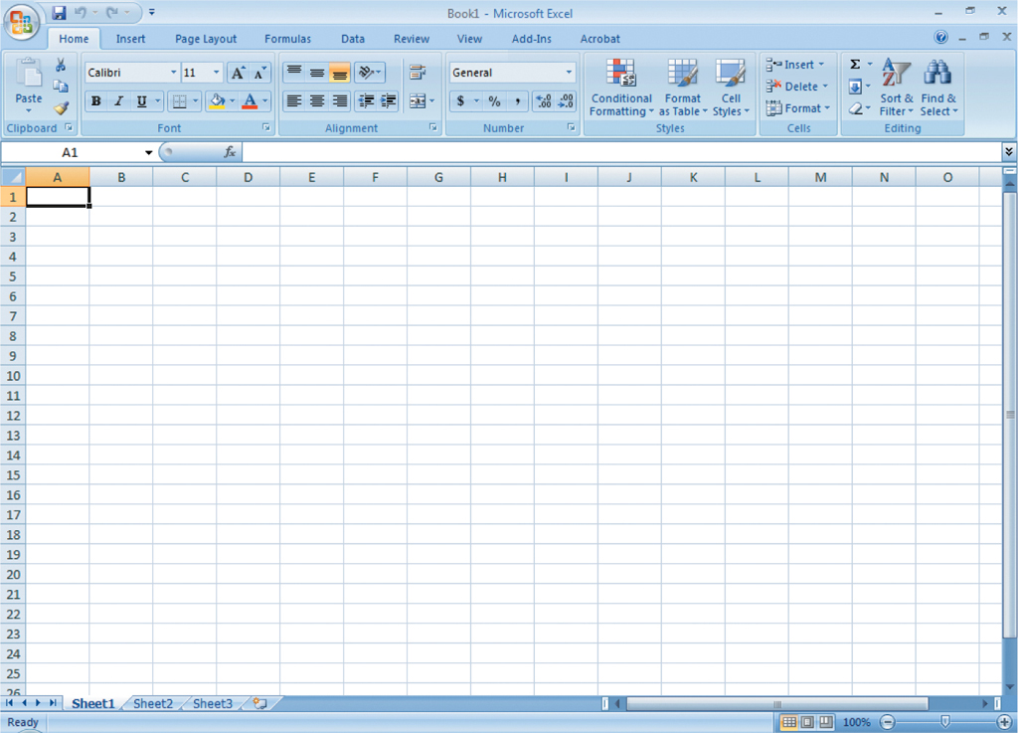
F
G
E
D
C
B
K
H
J
I
A
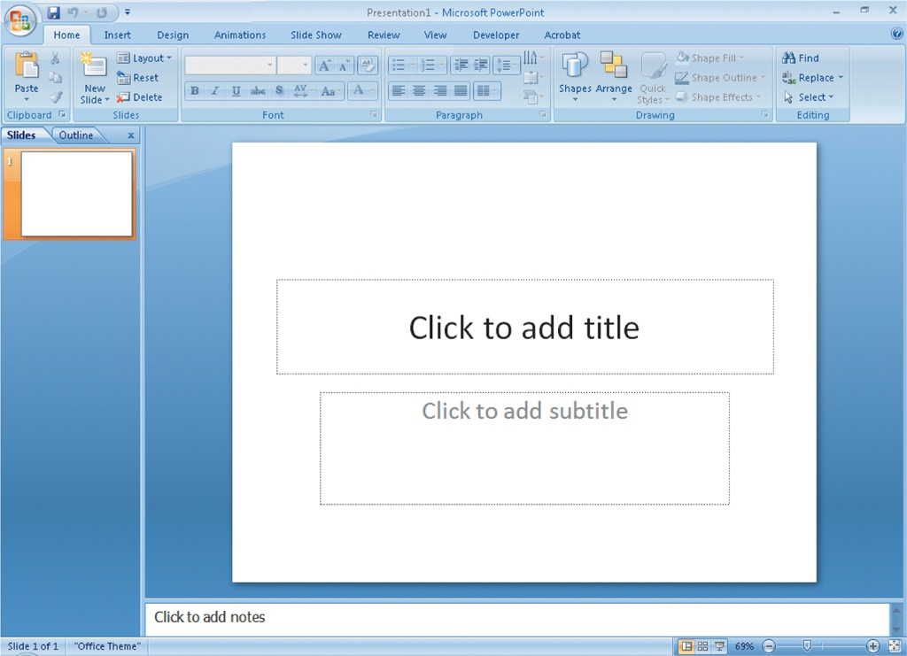
I
H
G
F
E
D
C
B
A
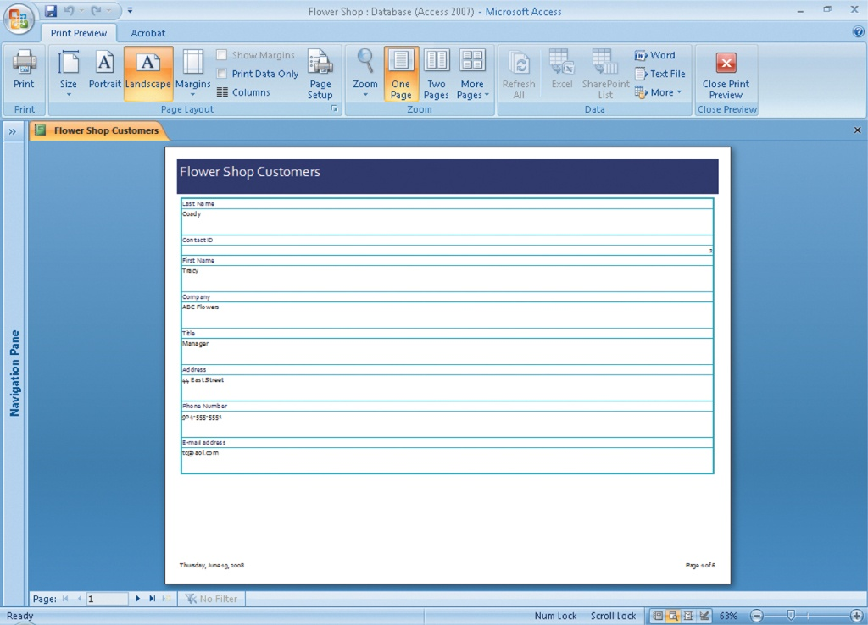
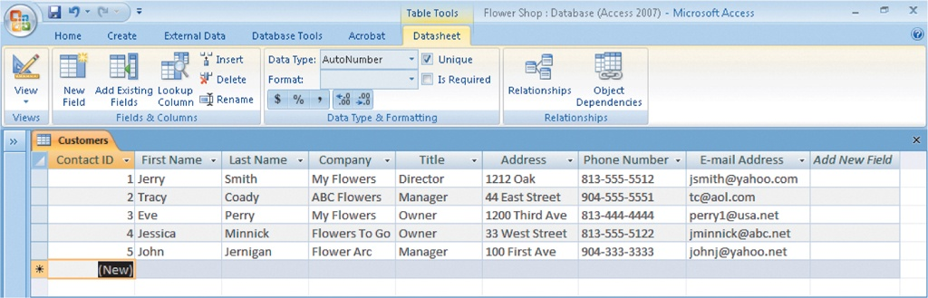
A
B
C
D
F
E

