Chapter 28 – Web Content

- Internet content is developed by __________________it on a Web page and providing links for ____________________________.
- As the author, you __________________ the content of the Web page and ________________ to it.
- With Web 2.0 you can allow other types of _________________________. Some of the ways you can create online content include:
  - _________________ and ___________________ are created by schools, government, institutions, companies, etc.
  - A _______________ short for _______________ is usually managed by ________ person or a small group. The author posts _____________________________________ _________________________________ . Entries are usually displayed in __________________- _______________________ order.
  - A ___________ is a collaborate Web site that can be ________________ by anyone with access.
  - Wiki means ____________in Hawaiian.
  - Social networking sites include: _________________ , _________________, and ______________________ (pick three you are most familiar with). You are also able to ________________________ and e-mail through these sites as well.
  - A _______________ is a collection of multimedia files, usually ______________ or video files that can be downloaded from the Internet to a ______________ device or PC.
    - You can download the files manually one at a time or through a subscription using _____________________________ (RSS).
    - To subscribe to a podcast, you use a software program called a ______________ which will check for a ___________ for new content on a regular basis.

- Circle the RSS feeds from the folders in the diagrams? How many RSS “Microsoft at Home” feeds do you see? ______________

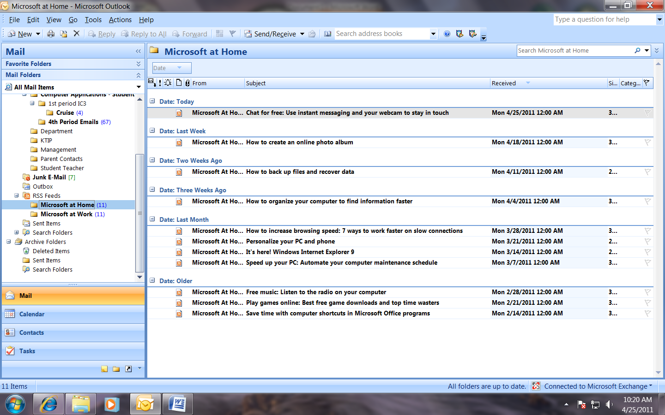

- When you share files using a Web site where others can use them, you use a ___________________________ (P2P) network. On Page 113, which peer-to-per media sharing site is displayed? _______________________.
- Can you think of any other media sharing sites? ______________________________________________________________________________
- A news feed is a ________________ format used for providing users with frequently updated content. In Windows Vista, you can add an RSS Feed ________________ to your desktop to display current headlines or up-to-date sports and weather information.
Searching for Information on the Web
- A search engine is: ______________________________________________________________ ______________________________________________________________________________
- To use a search engine, enter _____________________ that will help you narrow your search.
- In addition to search engines, you can find online information using other tools such as:
  - ______________________________________________________________________
  - ______________________________________________________________________
  - ______________________________________________________________________
- Almost all sites you visit will have ______________ which will allow you to easily click on the information you want.
Using a Search Engine
- If you want to search for works that appear next to each other, use _______________________.
- When you enter a phrase within ____________________________, the search engine will match those works that appear ________________________ to each other and in the order you specify.
- If you wanted to find all information about Fern Creek High School, how would you enter this into your search engine? __________________________________________________________
- If you did not put quotations around it, what would you search give you? ____________________________________________________________________________________________________________________________________________________________
- If you are search for more than one phrase, you can separate phrases or proper names with a _______________________. Capitalize proper nouns since some search engines distinguish between upper and lower-case letters.
- Math symbols are another available option to make ______________________ more specific and narrow your search results.
  - Insert a __________ sign before words that must appear, also called an ____________________ operator.
  - Insert a __________ sign before words that you don’t want to appear, also called an _________________________operator.
  - Using the example provided in the book, what would you expect if you entered a keyword search: +cookies+recipes? ________________________________________________________________________
  - What if you entered: +cookes+recipes+chocolate? ________________________________________________________________________
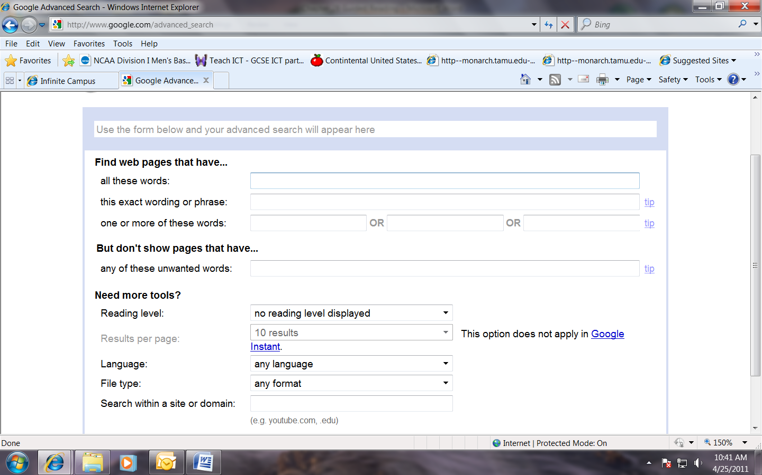
  - What if you entered: +cookes+recipes+chocolate-coconut? ________________________________________________________________________
  - Above is the advanced search for Google. Label which fields will include information and which will exclude information.
  - ________________________ logic is another way to search databases. You can use three _________________________operators: __________, __________, __________
- Using Boolean operators, write searches for:
  - Cookie recipes: ___________________________________________________________
  - Chocolate cookie recipes: ___________________________________________________
  - Chocolate cookie recipes without coconut: ________________________________________________________________________
- The _______ symbol, or asterisk, is a __________________ character. If you don’t know how to spell something or you want to search for __________________ or variations of a word, use the * to fill in the missing letters.

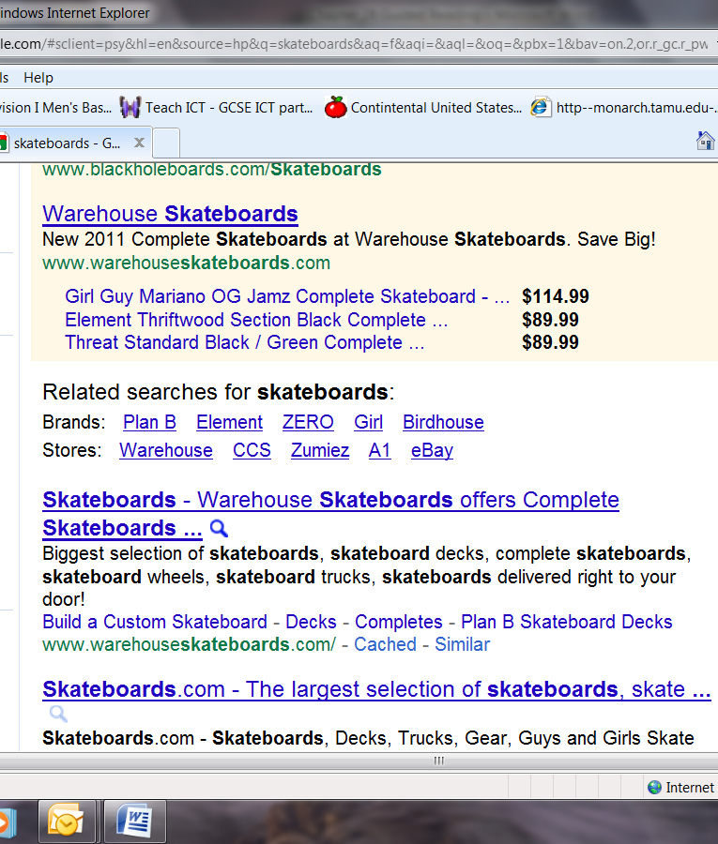
- On the right you can see a search for skateboards. The black arrow is pointing to ________________. When you click on this link, you will be taken to websites that are ____________________________________________________________________________________________________________.

Evaluating the Quality of Internet Information
- The _______________________does not enforce rules or quality controls about content. You should not accept everything as _______________________.
- Guidelines you should consider:
  - _______________________________________________________________________
  - _______________________________________________________________________
  - _______________________________________________________________________
  - _______________________________________________________________________
  - _______________________________________________________________________
- Copyright is: ____________________________________________________________________________________________________________________________________________________________________.
- How do you avoid copyright infringement? ______________________________________________
- What is a trademark? _______________________________________________________________
- What is a patent? ___________________________________________________________________
- If a copyright or patent protection has lapsed on certain material, it is considered _________________________ and is available for anyone to copy or use.
- What is “fair use”? __________________________________________________________________
- If you don’t cite your sources and claim work that is not your own you are engaging in ____________________________.
- What is libel? ______________________________________________________________________
- How can it occur using the Internet? ____________________________________________________________________________________________________________________________________________________________________
- List three suggestions for being responsible when publishing information online.
  - _____________________________________________________________________
  - _____________________________________________________________________
  - _____________________________________________________________________

