Chapter 27 – Using the Internet and the World Wide Web
Guided Reading – Pages Mod3-73 - 105

Vocabulary
Type | Description/Example
Client

File Transfer Protocol (FTP

Hit

Hypertext Markup Language (HTML)

Internet Protocol (IP) address

Web site

The Internet and the World Wide Web
- What is the most popular service for the Internet? ______________________________________
- True or False The Internet is the same thing as the World Wide Web?
- _________ was the first graphical browser.
- What browser do we use here in this classroom? __________ _________
- List for me some other browser’s you may use at home or other places.
  - __________________
  - __________________
  - __________________
- In 1994, ________ ______________ cofounded Netscape Communications.
- Web 2.0 includes a new generation of Web-based services such as:
  - _________________________
  - _________________________
  - _________________________
  - _________________________
- _________ ______ is a set of rules that controls Windows applications that are downloaded from the Internet and then run in a browser.
- What are Cookies and what are they used for? (found on page 3-77 figure 27-3)
________________________________________________________________________________________________________________________________________________________________________________________________________________________________________________________________________________________________________________________________________________________________________
- A __________________ ____________________ is an electronic document similar to an ID card. This digitally signed statement verifies the identity of a person or company and confirms that they own a public key.
- What are the top-level domain names:
  - _______________
  - _______________
  - _______________
  - _______________
  - _______________
- When data is sent over the Internet, it is sent in __________.
- _____________ is the process of converting text into an unrecognizable format when it is sent and changing it back(____________) into plain text when it reaches its destination. This process is used for sensitive online transactions, such as __________ _________ purchases.
- A __________ _________ is the first page that appears in the browser when you visit a Web site.
- What is Jefferson County’s Public School Home Page? ____________________________________________________________
- An ___________ ___________ _____________ is an organization or company that provides connectivity to the Internet through a telecommunications line or wireless system.
- What ISP do you use at home? (Who do you pay to get Internet service at home?) __________________________________________
- A ____________ is a downloadable audio broadcast.
- ___________ ___________ _________________ is a format originally developed to syndicate new articles online.
- ___________ ___________ _____________ is a protocol for managing the security of message transmissions on the Internet.
- What is the address of a Web page called? ________________________________________________________
- A ______ _________ is a temporary storage area on your computer for collecting data. Once the data is stored in the _______, a Web site can quickly access the stored copy rather than downloading the data again.
- A _______ is a collaborative Web site that people can use to add, edit, remove, and organize Web page content.
- When might a Wiki be beneficial to a student? ________________________________________________________________________________________________________________________
- What are the different types of Web sites available:
  - ________________________________________
  - ________________________________________
  - ________________________________________
  - ________________________________________
  - ________________________________________
  - ________________________________________
  - ________________________________________
  - ________________________________________
  - ________________________________________
  - ________________________________________
  - ________________________________________
  - ________________________________________

- Label the different types of Web sites below.
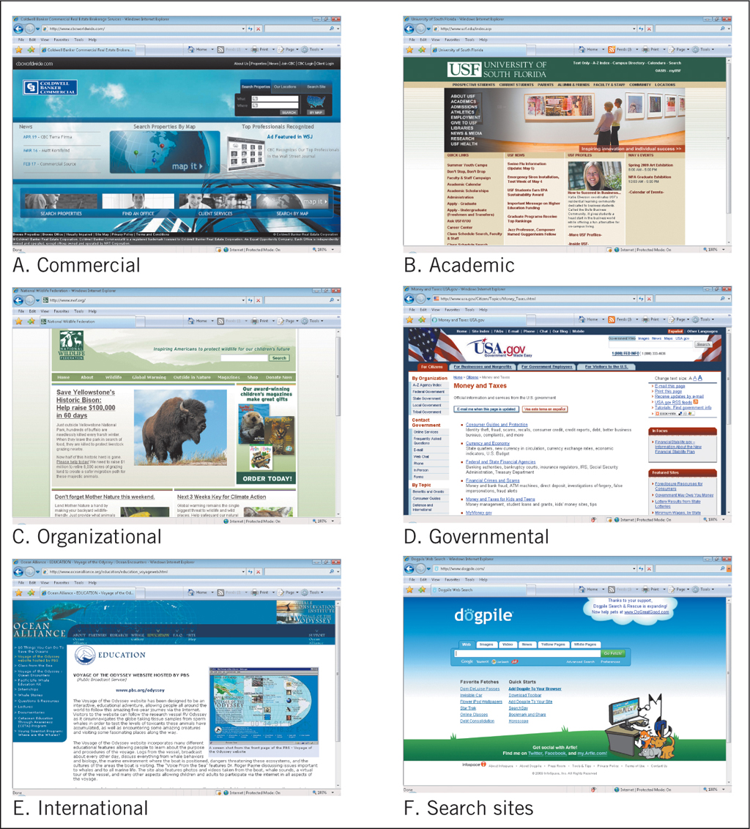
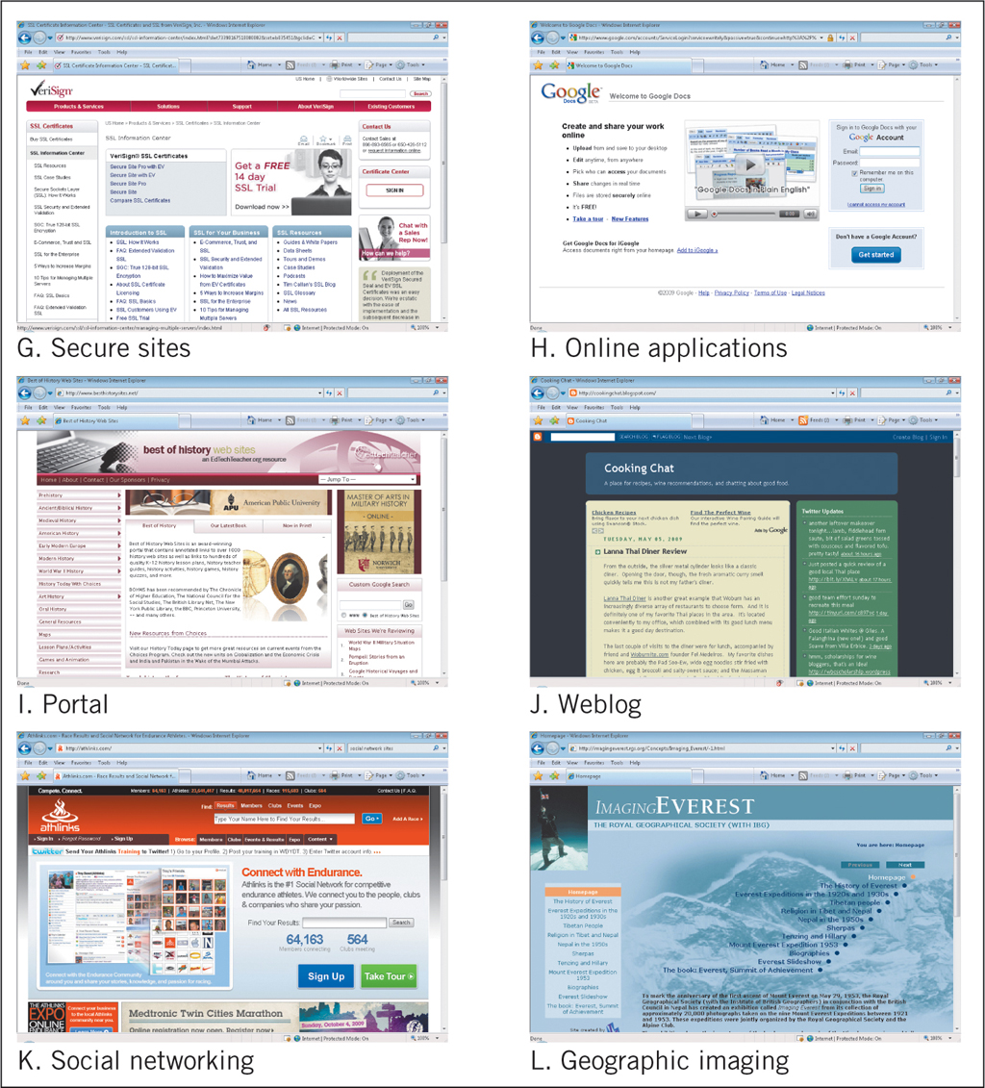
- If you connect to the Internet from an office or academic setting, you probably are connecting through a ________ ________ _____________. You connect to the Internet using a __________ _____________ ______ which is found inside your computer that allows the computer to be ______________.
- Here at Fern Creek, what are we connected too, (WAN or LAN)?
- What are the steps you must do in order to connect to the Internet?
  - _____________________________________________________
  - _____________________________________________________
  - _____________________________________________________
- Connections can transmit multiple channels of information over a single link, so they can carry (what) simultaneously?
  - ________________________
  - ________________________
  - ________________________
______________ __________ connections allow home computer users to enjoy the benefits of faster connection speed and multiple channels to transmit data.

- Label the different parts of the Browser Window
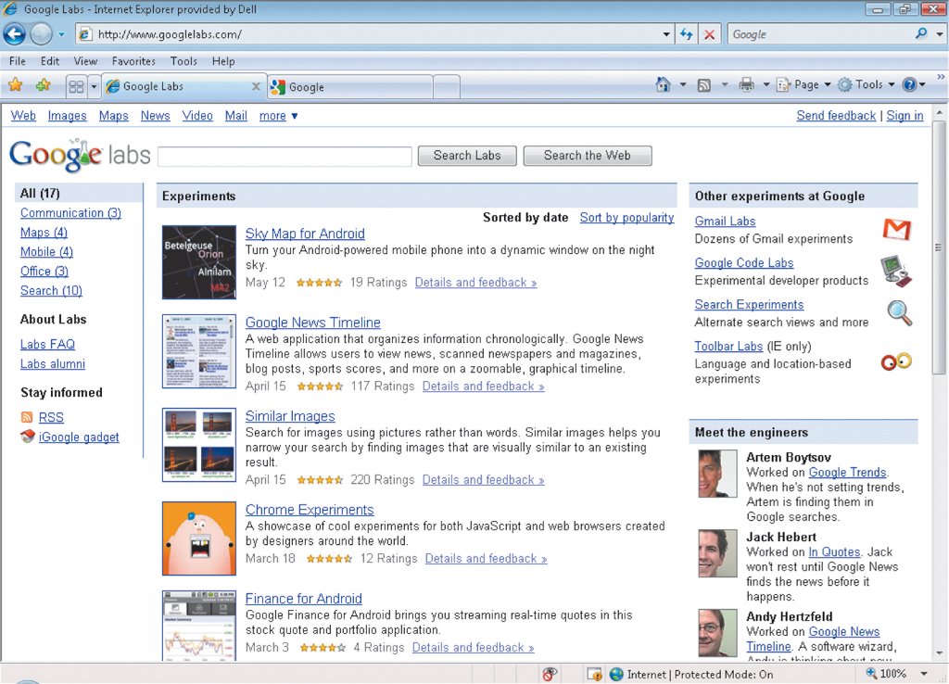
- Place the correct term next to the correct definition.
COMPONENT | DEFINITIONS
 | The bar on top of the window that contains the name of the document
 | Located at the bottom of the browser; shows the progress of Web page transactions
 | Vertical and horizontal scroll bars that let you scroll vertically and horizontally if the Web page is too long or too wide to fit within one screen
 | Displays a thumbnail of open web pages; this button is displayed when you have more than one Web page open
 | Lists menu commands if you select the option to display the menu bar
 | Displays the active Web page
 | Displays the page you viewed prior to the current page displayed in the browser window
 | Contains the URL or address of the active Web page; also, where you type the location for the Web page you want to visit
 | Displays a list of all open Web pages
 | Lets you search for Web pages containing information that you specify

COMPONENT | DEFINITIONS
 | Refreshes or reloads the current Web page
 | Tabbed browsing lets you open multiple Web pages within the same browser window
 | Displays the next page in the series of pages you have previously viewed; this button is not active until the Back button has been clicked at least one time
 | A horizontal toolbar located on the right side of the window; provides a selection of options used to execute common commands

- The default settings in Internet Explorer is to keep track of sites visited for approximately how long?_______________________
- You can view a list of recently visited Web sites by clicking the Favorites Center button and then click the History button. Clicking the History button arrow displays a list of View Options. What are they?
  - _____________________________
  - _____________________________
  - _____________________________
  - ______________________________
- What are the different reasons you may receive a “404 error message”.
  - _______________________________________________________
  - _______________________________________________________
  - _______________________________________________________

Assignments and Projects
Chapter 27 – Car Loan Calculator | 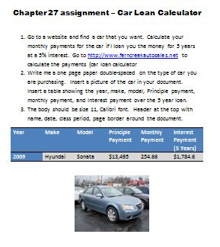
Chapter 27 – Who are they? | 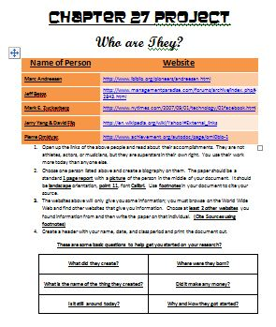
Chapter 27 – Internet Research on Real World Issues | 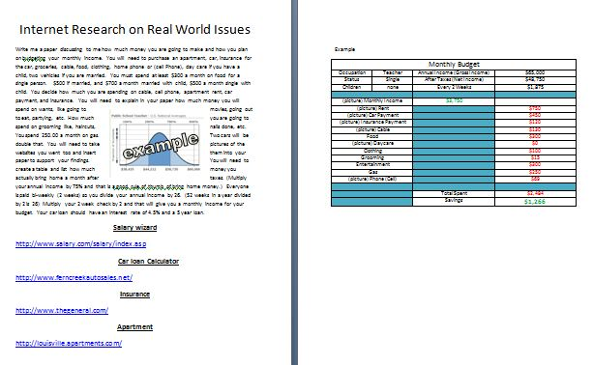
Chapter 27 – Rubric for Research Project | 