10 Amusement / Water Parks
List for me using the number button 10 amusements/ water parks that you would like to go!
- Write a paragraph for each place why you want to go there.
- Give me 3 bullets of cool information or facts about the place.
- Insert a picture so that the words wrap around it.
- Hyperlink the name of the place to the places website.
- Make the name size 18, bold, choose any font you want.
- Use standard formatting (size 12, arial or times new roman font) for the paragraph and bullets.

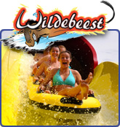
- Holiday World
My son loves to ride roller coasters. It is a lot of fun to go there and hang out with the family. Not only do they have really cool rides, but they have a huge water park. I usually go to Holiday World once or twice a year in the summer.
- Give free soft drinks
- Located in Santa Clause, IN.
- Have a new ride called the Wildebeast.

